# Email Verification Steps:

## Step 1:

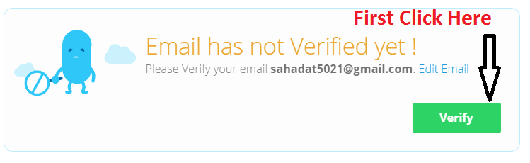

## Step 2: step_2.png

After that you will get the email verification mail.